**Biological Systems Presentation**

Name:________________________________________

Task: Individually, you are to compare and contrast how body systems work in mammals compared to a non-mammalian living organisms (plant or animal).

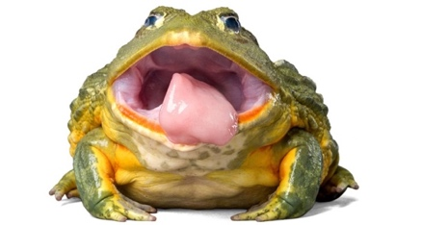Choose **one** of from the following list to focus on:

* The circulatory system between a mammal and a frog
* The respiratory system between a mammal and a fish
* The reproductive system between a mammal and a flowing plant

You may choose the species of organism to research eg. choice of mammals include human or dolphin etc.

The focus of this research is to identify the similarities and differences of the chosen system in different organisms and how it helps the organism to survive.   
  
**Include the following key points**:

* The function of the system
* The organs which make up the system
* The structure of an organ in the system and how it functions in system
* The similarities and differences in the system between chosen organisms
* How the differences **effectively** help the organism to survive and/or reproduce

You must prepare this assessment in the format of a **PowerPoint presentation.**

.

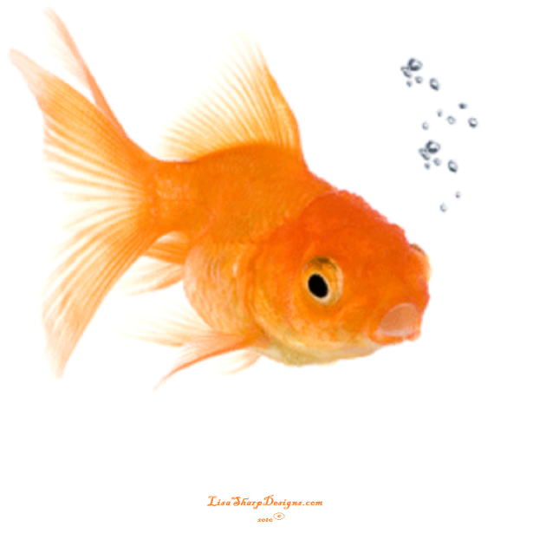

**Biological Systems Presentation**

**MARKING KEY**

Student name:___________________________

|  |  |  |
| --- | --- | --- |
| **CONTENT** | Possible marks | Your mark |
| Organism of choice is classified as mammalian and either frog, fish, or flowering plant | 2 |  |
| Describes function of system | 1 |  |
| States organs present in each organism | 2 |  |
| Describes the structure of an organ in detail for each organism | 2 |  |
| Relates structure of organ to function of system | 1 |  |
| States at least two (2) similarities between system in chosen organisms | 2 |  |
| Contrasts at least two (2) differences between systems in chosen organisms | 2 |  |
| Explains how one of these differences allows the each organism to effectively survive | 2 |  |
| **PRESENTATION** |  |  |
| Correct spelling and grammar | 1 |  |
| Uses simple language (in own words) | 1 |  |
| Visually engaging | 2 |  |
| Uses multiple relevant diagrams/images to support explanation | 2 |  |
| **REFERENCES** |  |  |
| Includes more than five references (1) and in correct format (1) | 2 |  |
| **TOTAL** | **22** |  |
|  |  |  |